Virtual Reality

Assignment 1: Roll a Ball

1/17/2017

I felt like this was a really awesome way to get introduced to not only Unity, but also programming in C#. The tutorial taking the form of a walk through really made it easy for me to follow along, take notes in my own pace and work to develop the game.

First I’ll start off with some issues I experienced. Most of the time I was able to get past the issues by tinkering, googling, or continuing on with the tutorial but some things I was struggling with was the camera location of both the scene window and the game window and getting the documentation to pull up in the way that the instructor was describing. I was able to get the camera angles to focus how I wanted to eventually but I felt like one more change would mess things up and it would be hard to fix. That’s something I need to work on going forward. Also, I was scripting in visual studio, so that is probably why I couldn’t pull up the documentation using the control + ‘ command.

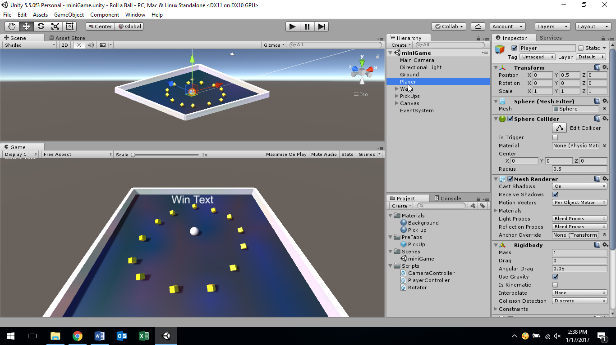

The tutorial gave instruction on how to change the game camera view and thankfully I was able to copy the instructor’s layout view for the scene, project, inspector etc. After getting the layout correct, it made the development process that much easier.